1.To Create Process Escape Sequences, Handle Escaped Spaces, Escape Special Symbols, Preserve Characters, Validate Parser Output, Test Complex Inputs
2.To Create Child Processes, Execute Programs, Handle Execution Errors, Pass Arguments, Manage Parent Process, Test Command Launching
Code:
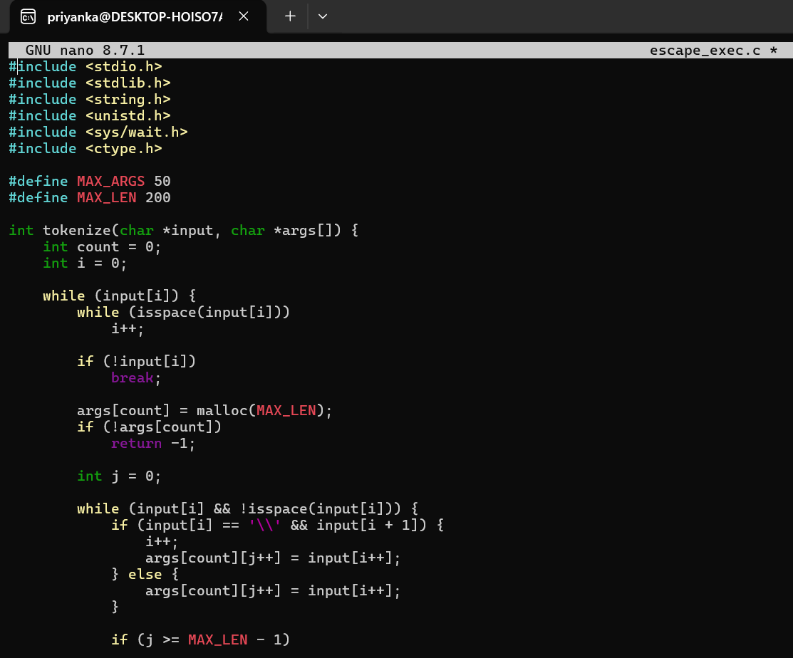
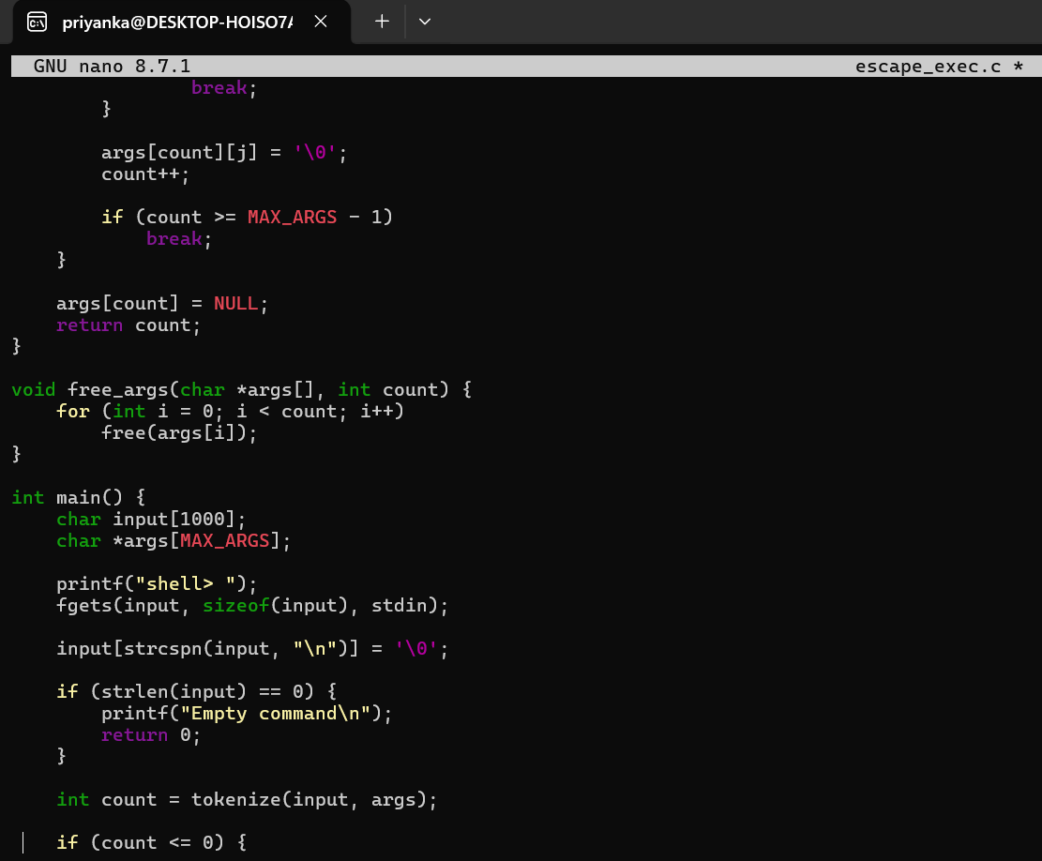
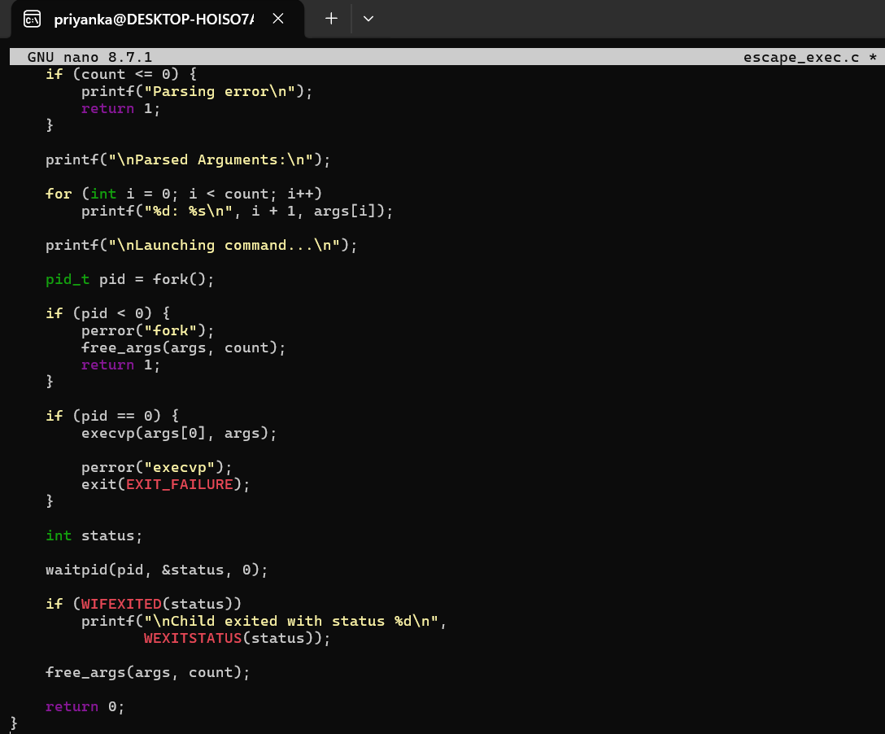
Output:
